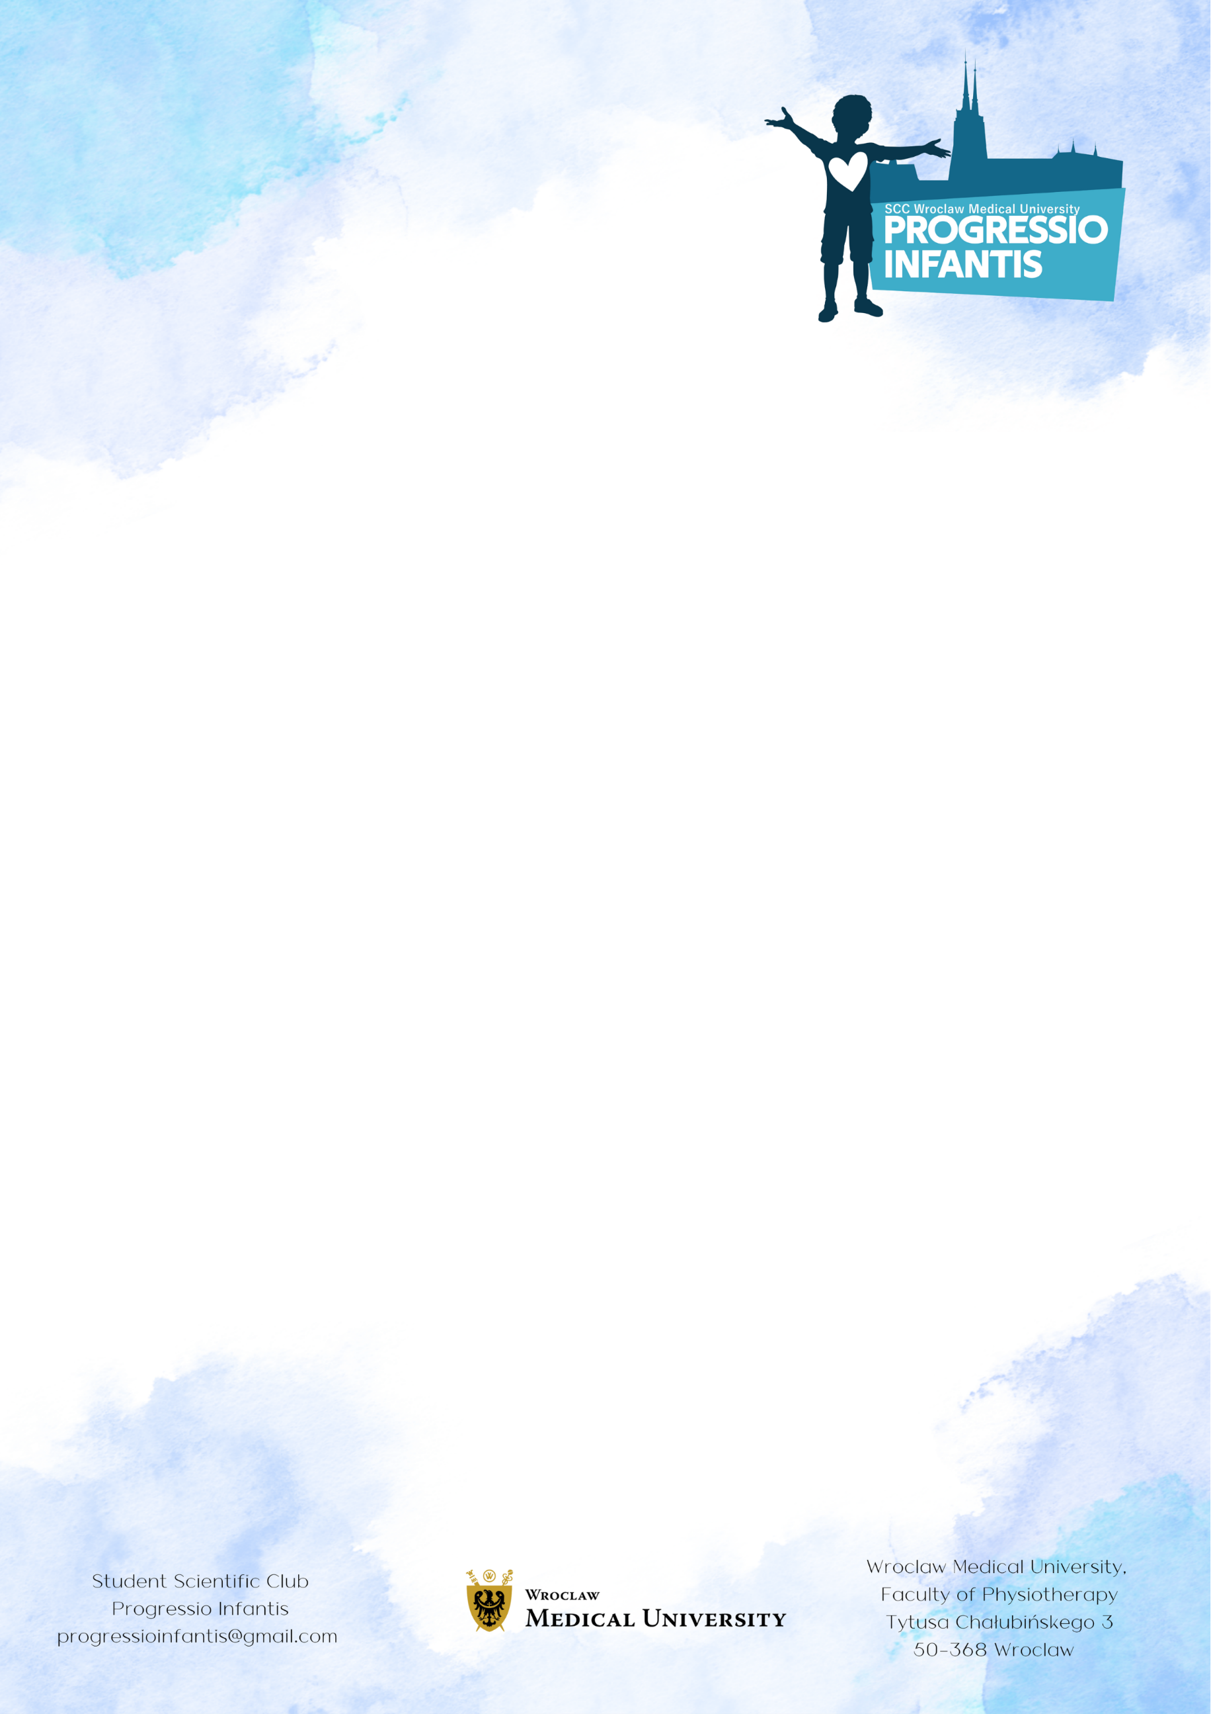
Title of the abstract in English
Last Name First Name ¹, Last Name First Name ²
1Affiliation of the first author
2Affiliation of another co-author
e-mail address for correspondence
Keywords. minimum 3, maximum 5 keywords
Introduction. The length of one abstract is 1000 to 1500 characters with spaces; the abstract should be written in an impersonal form; should not contain a bibliography; the abstract in the form given will be placed in the book of abstracts.
Material and methods. The text of the introduction in English should be here.
Results. The text of the results in English should be here.
Conclusions. The text of the conclusions in English should be here.
The font size and type should be as in the model summary. The file with the summary should be sent as an attachment to the conference e-mail address:progressioinfantis@gmail.com

